
U.ae User Guide
Table of Contents

Introduction 4
1. Top navigation bar 5
2. Homepage banner 6
3. Life in the UAE 7
4. Stay in Touch 8
5. UAE Future Roadmap 9
6. UAE Digital Participation Hub 10
7. Featured initiatives 11
8. Map 12
Services 13
1. Accessing the ‘Services’ page 13
2. Search and filter services 13
3. Start service 14
Life in the UAE 14
1. Accessing ‘Life in the UAE’ page 15
2. Viewing details 16
3. Service Statistics 16
4. Most Used Digital Services 17
5. Service-related information 18
6. Featured videos 19
About The UAE 19
1. Accessing the ‘About the UAE’ page 19
2. Viewing details 20
3. Featured information 20
Media 20
1. Accessing the Media page 21
2. News, events and videos 22
These sections contain news, events and videos relating to the UAE Government. 22
22
22
3. Other types of media 23
4. Media Information 23
Year of Family 23
1. Accessing the ‘Year of Family’ page 24
24
2. Related Services 24
3. Family and Society 24
4. Social and Family Programmes 25
5. Partners 26
Footer navigation 26
1. The platform 26
2. Other Websites 27
3. Help and Support 27
4. Emergency Contacts 27
5. Follow Us On 27
6. Legal links 27
7. Floating side icons 28

Introduction
Welcome to the User Guide to the U.AE platform.

This guide is designed to help you navigate, explore and utilise the U.ae platform effectively. U.ae is the official platform of the United Arab Emirates Government. It provides access to government information, services, initiatives and digital resources on one centralised platform.

Whether you are a citizen, resident, visitor, employed professional, business owner or a student, you can use this guide to:
- search for and get government information and services
- explore the UAE Government information, strategies, initiatives, digital programs, etc.
- navigate the platform’s main sections and service categories
- access useful resources, official links and support channels, and
- make the most of the platform’s features to quickly find the information and services.

By following this guide, you will be able to use the U. ae platform with confidence, access official government information and services efficiently, and benefit from a seamless digital experience.

Homepage overview
When you log on to “https://u.ae/”, you will land on the homepage of U.ae, the official digital gateway to the United Arab Emirates. The homepage serves as the starting point for accessing government information, services, initiatives and digital resources. The platform is designed with a user-friendly interface that enables you to quickly search for information, navigate key sections and access government services with ease.

- Top navigation bar
The top navigation bar provides direct links to the main sections and features of the U.ae platform.
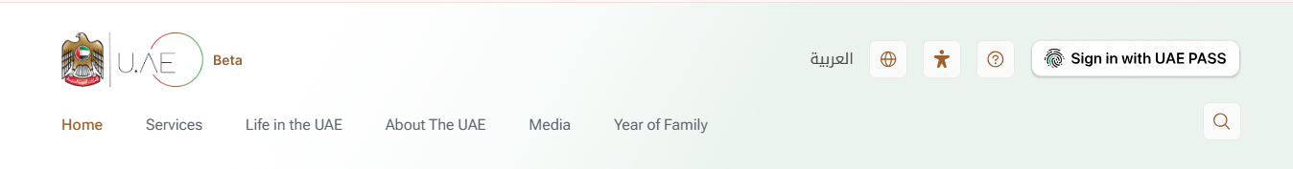
The main sections are:
- Home – it lets you return to the U.AE homepage at any time
- Services – it opens a directory of services through which you can browse and access the UAE Government’s services across different categories
- Life in the UAE – it provides information about living, working, studying, investing and visiting the UAE
- About the UAE – it contains information about the UAE, its government, history, leadership, policies and national strategies
- Media – it is a repository of the latest news, announcements, photos, videos and other media content
- Year of Family – it provides information about initiatives, programmes and related information supporting the UAE’s decision to dedicate the year 2026 as the Year of Family
- Language – it switches the platform between English and Arabic languages
- Accessibility– it has options for accessibility settings that you could use to enhance your browsing experience and improve usability
- Help – it takes you to resources, guidance and assistance for using the platform
- Sign in with UAE PASS – it takes you to the UAE’s national digital identity and signature solution so you can access personalised government services and features
- Search – it is an internal tool to find information, services or content across the platform quickly.

- Homepage banner
The homepage banner showcases featured information, government initiatives and key services available on U.ae. It provides quick access to important content through rotating banners with clear call-to-action buttons.
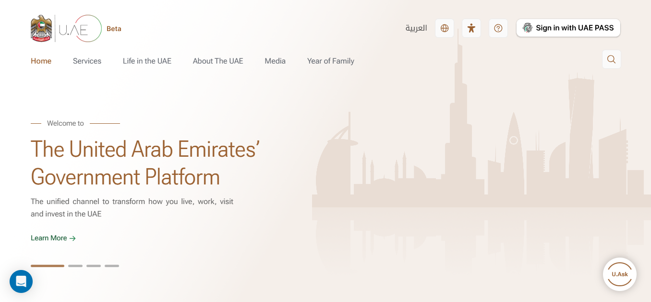

The banner includes featured slides. Currently, it has banners for:
- U.ASK – it provides fast and accurate answers to questions about UAE Government information and services using AI. Select ‘Learn More’ to explore the feature.
- The United Arab Emirates’ Government Platform – it introduces U.AE as the unified digital platform for accessing government information and services related to living, working, visiting, investing in the UAE and doing business in the UAE.
- Every Person Matters – it highlights the UAE Government’s commitment to inclusive digital services that are accessible, user-centric and designed to meet the needs of everyone.

Use the slider controls located at the bottom of the banner to navigate between the featured slides. Each slide includes a ‘Learn More’ button that directs you to the related page or service for additional information.

- Life in the UAE
The ‘Life in the UAE’ section provides comprehensive information and services to support living, working, studying, visiting, investing and doing business in the UAE. This section is organised into clear categories to help you find the information you need quickly.
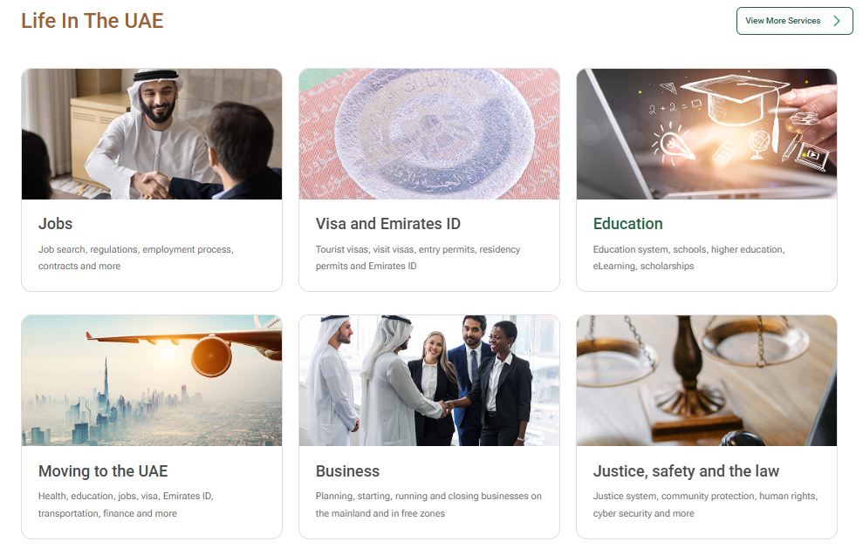
The categories include amongst others:
- Jobs – Find information on job opportunities, employment regulations, employment processes, contracts, employee rights and more.
- Visa and Emirates ID – Learn about tourist and visit visas, entry permits, residency permits, Emirates ID services related application and renewal services.
- Education – Explore information about the education system, schools, higher education, vocational education, eLearning, scholarships, qualifications and related services.
- Moving to the UAE – Access practical guidance on relocating to the UAE including information on healthcare, education, jobs, visa, Emirates ID, transportation, finance and other important topics for moving to the UAE.
- Business – Find guidance on planning, starting, running, and closing business in the UAE, including information on mainland and in free zone businesses.
- Justice, Safety and the Law – Access information on the UAE legal system, public safety, community protection, human rights, cyber security and related government services.

- Stay in Touch
The ‘Stay in Touch’ section keeps you informed about the latest UAE Government news, events and multimedia content. This section provides timely updates on government initiatives, national announcements and public activities.
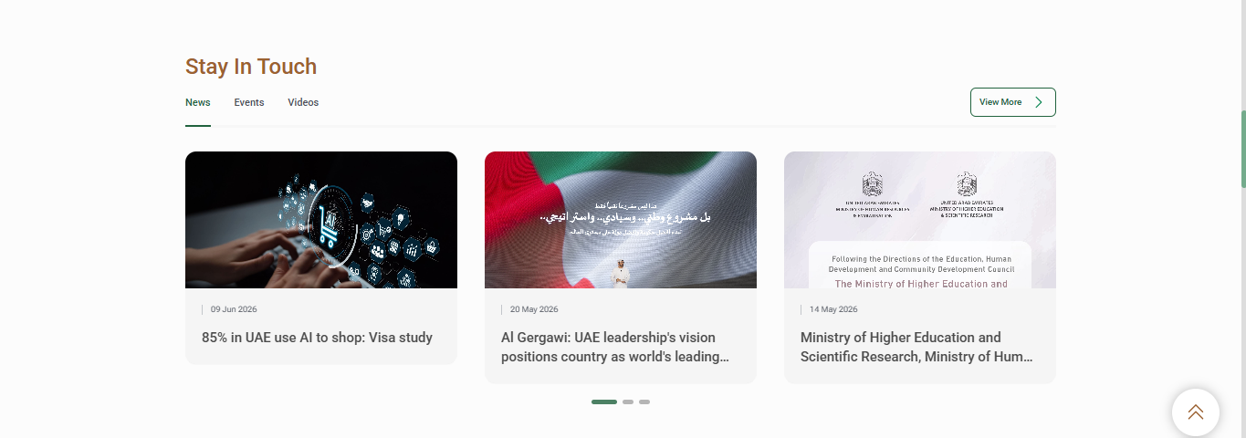
The section includes three main tabs:
- News – browse the latest government news, announcements, and updates.
- Events – explore upcoming or recent events related to government initiatives and public activities.
- Videos – watch media content and videos published on the platform.

Each item displays key information such as image, publication date and title. You can click on any item to open the full page and view more details.

Use the slider controls to browse more items within each tab or select ‘View More’ to access the full list of news, events, or videos.

- UAE Future Roadmap
The UAE Future Roadmap section provides an overview of the UAE’s long-term vision, strategic plans and national milestones across different time periods. It enables you to explore the country’s future aspirations and key development initiatives.
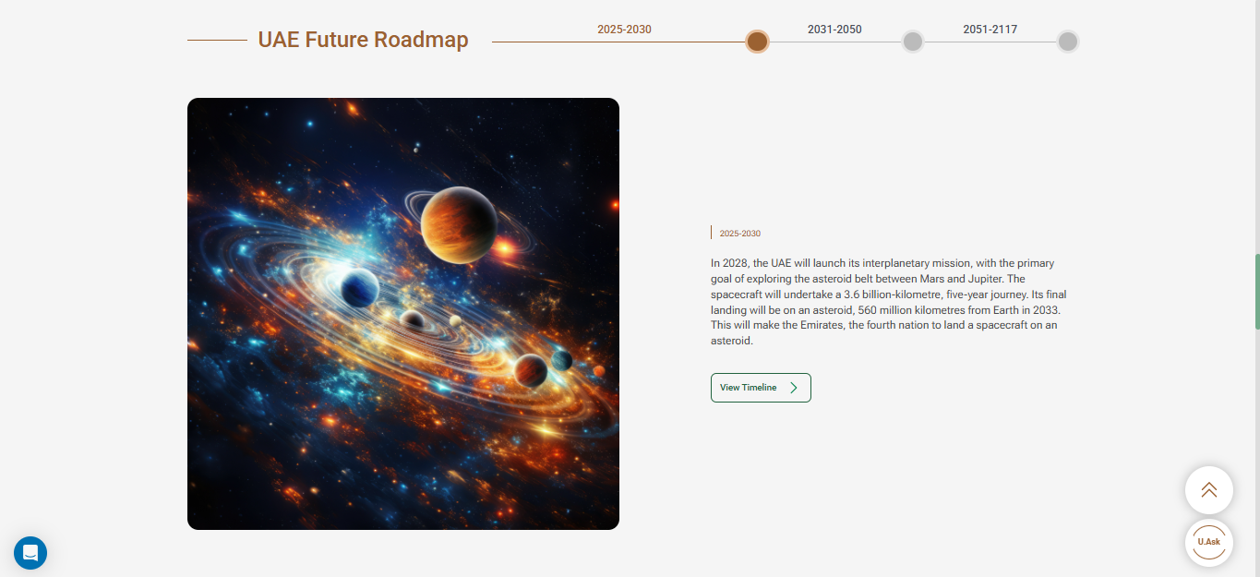

In this section, you can:
- explore roadmap for the years 2025–2030, 2031–2050 and 2051–2117
- view the key national initiatives and strategic priorities associated with each phase
- read a brief description of each initiative to understand its objectives and expected outcome
- click on ‘View Timeline’ to view details and learn more about the selected phase.

- UAE Digital Participation Hub
The UAE Digital Participation Hub has several channels that enables you to share your opinions, ideas and thus, participate in shaping government services, policies and initiatives.
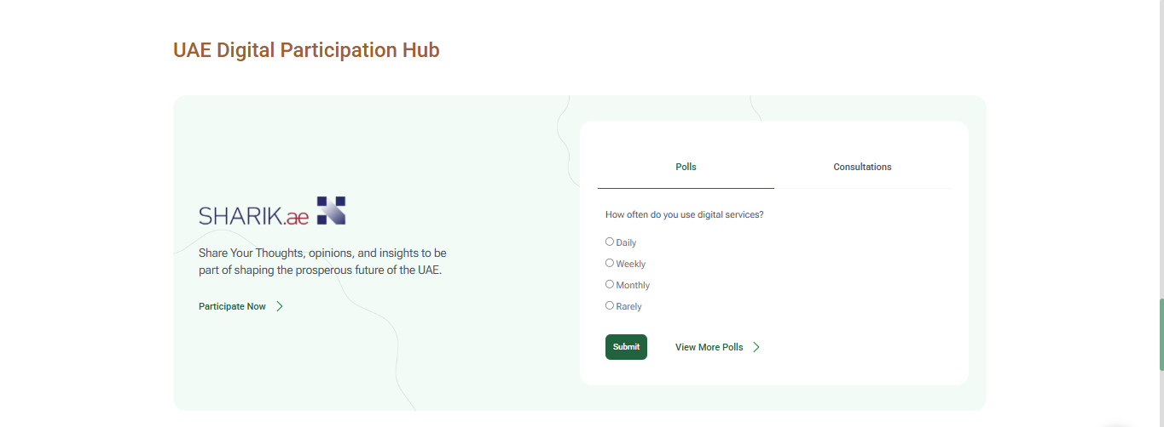
In this section, you can:
- access Sharik.ae, the UAE’s national digital participation portal
- participate in polls and public consultations on a variety of government topics
- click on ‘View More Polls’ or ‘Participate Now’ to explore additional opportunities to engage with government entities and contribute your feedback.

- Featured initiatives
The ‘Featured Initiatives’ section shows key national initiatives, programs and campaigns highlighted on U.AE. It enables you to discover strategic initiatives and learn about their objectives and impact.
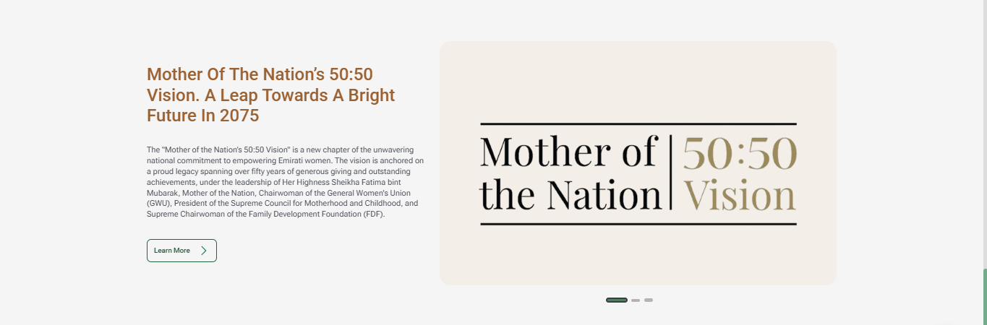

In this section, you can:
- view featured initiatives, which include a title, short description and related image
- select ‘Learn More’ to view details about the initiative, and
- use the slider controls to browse more initiatives.

- Map
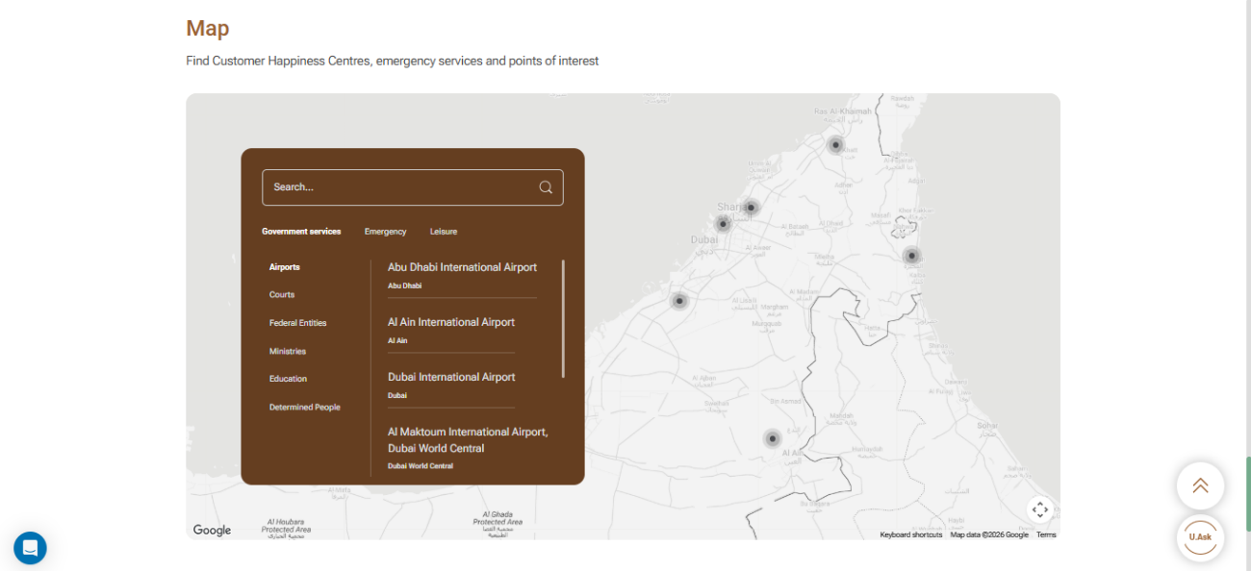
The ‘Map’ section helps you locate Customer Happiness Centers, government offices, emergency services centres, and points of interest across the UAE. It provides an interactive map that makes it easy to search for locations and explore nearby services.
In this section, you can:
- search for a specific location or service using the search bar
- browse locations by categories such as Government services, emergency and leisure
- find locations of sites under each category on the map
- select a listed location or location pins to view more details.

Services
The ‘Services’ page provides centralised access to key federal government services in one place. It enables you to search, filter and browse services based on your needs.
- Accessing the ‘Services’ page
- Select ‘Services’ from the top navigation bar.
- Browse the available government services displayed on the page.
- Search and filter services
The search and filter features help you quickly find government services that match your requirements.
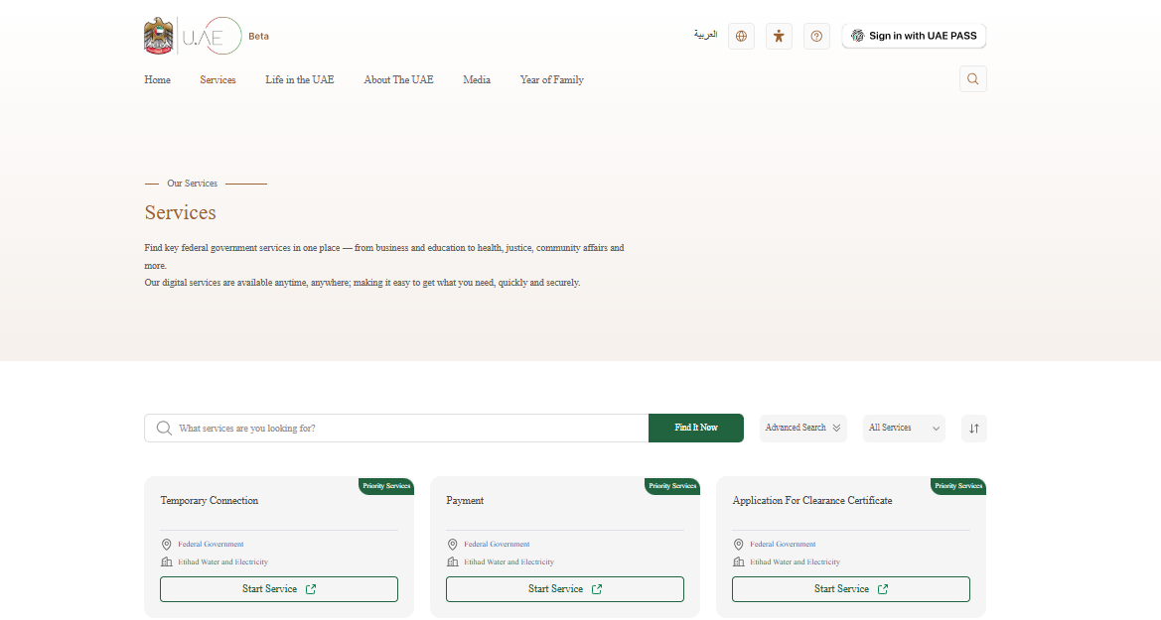
In this section, you can:
- enter a keyword in the Search bar to find a specific service and
- click on ‘Find It Now’ to display matching services.

Alternatively, you can:
- use the advanced search to refine the results based on the available filtering options: Federal/Local, Entity and categories or
- click on the ‘All Services’ dropdown list to browse services by category.

Additionally, you can use this sort of option to arrange the services in alphabetical order.

After using the search tool or applying the filters, the platform displays the services that match the selected criteria.
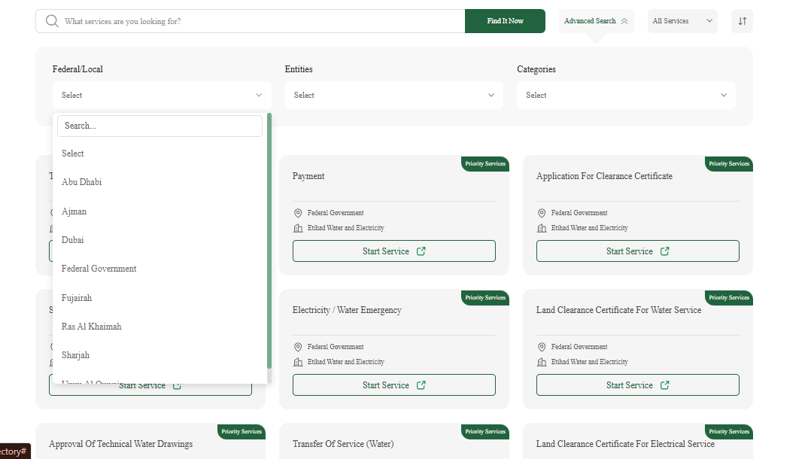
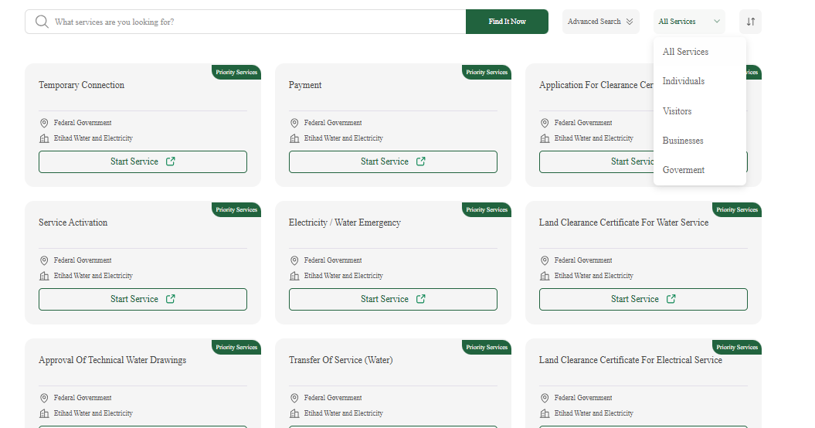

- Start service
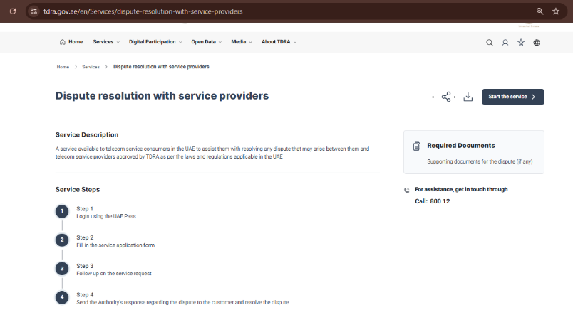
Once you select a service, you can begin the application process.
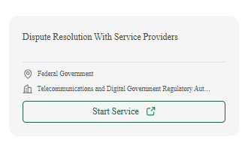
The process involves clicking on ‘Start Service’ to begin the application process. (The platform may redirect the user to the website or service platform of the government entity responsible for providing the service.)
- Sign in using UAE Pass to access and complete the service.
- Follow the steps displayed on the service card to submit your service request.

Life in the UAE
The ‘Life in the UAE’ page displays various service topics which contain trusted information and useful guides about living, working, studying, visiting, investing and doing business in the UAE.
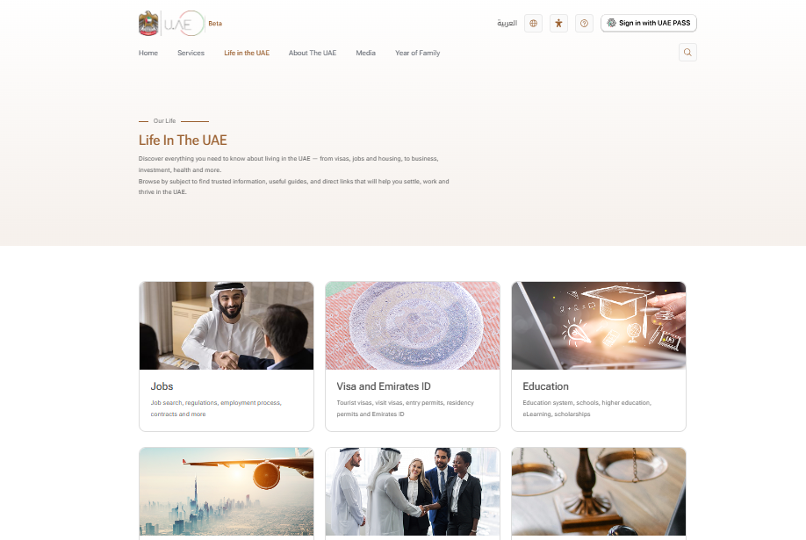
- Accessing ‘Life in the UAE’ page
- Select ‘Life in the UAE’ in the top navigation bar.
- Browse the available topics:
- Jobs
- Visa and Emirates ID
- Education
- Moving to the UAE
- Business
- Justice, safety and the law
- Visiting and exploring the UAE
- Transportation
- Finance and investment
- Environment and energy
- Housing
- Passports and travelling
- Health and fitness
- Public holidays and religious affairs
- Infrastructure
- Connected government (G2G)
- Social affairs
- Charity and humanitarian work.
- Click on any topic to view sub-topics under it.

- Viewing details
Each sub-topic provides detailed information, related government services and useful resources.
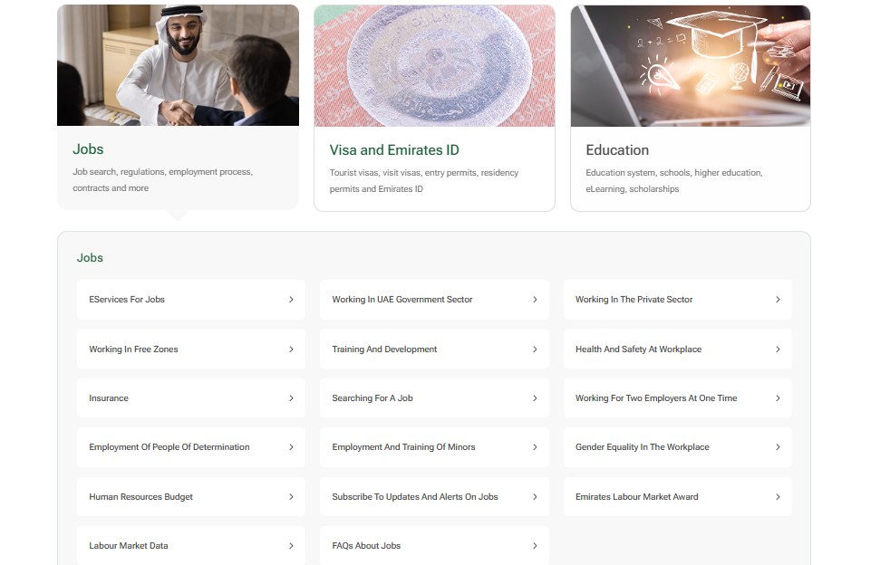

To view a sub-topic,
- click on a sub-topic card and
- find detailed information, guidance and related resources.

- Service Statistics
The ‘Service Statistics’ section provides statistics relating to the services of the UAE government.
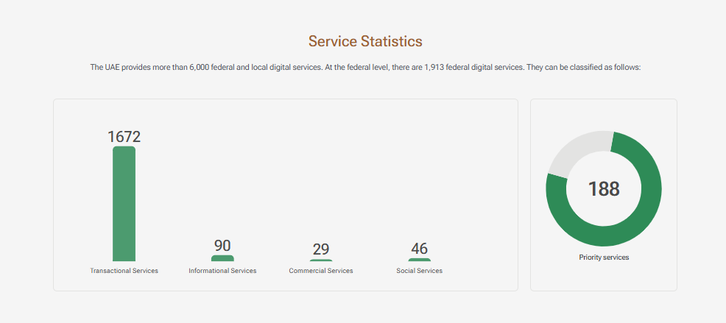

The statistics are organised by service type as follows:
- transactional
- informational
- commercial
- social and
- priority services.
The statistics displayed are updated periodically.

- Most Used Digital Services
The ‘Most Used Digital Services’ section shows the most frequently used digital services in a particular year. It provides users with insights into the services that are most accessed through the UAE government’s digital channels. In this section, you can view the list of most used services along with the number of times it was used.
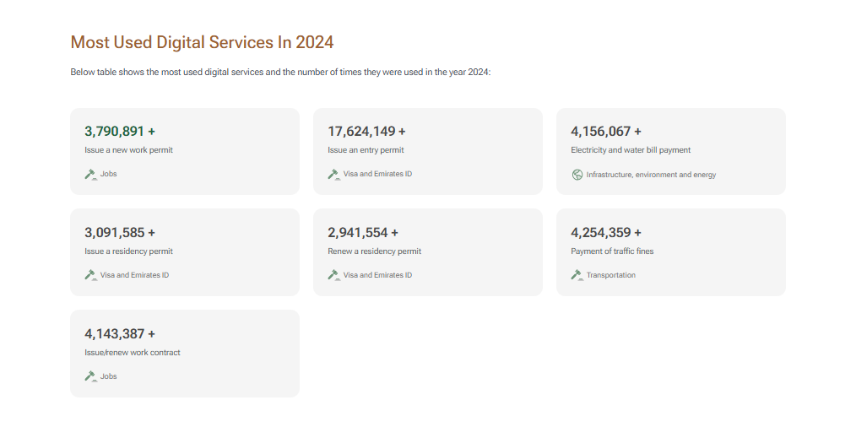

- Service-related information
This section provides quick access to topics and resources relating to digital services.
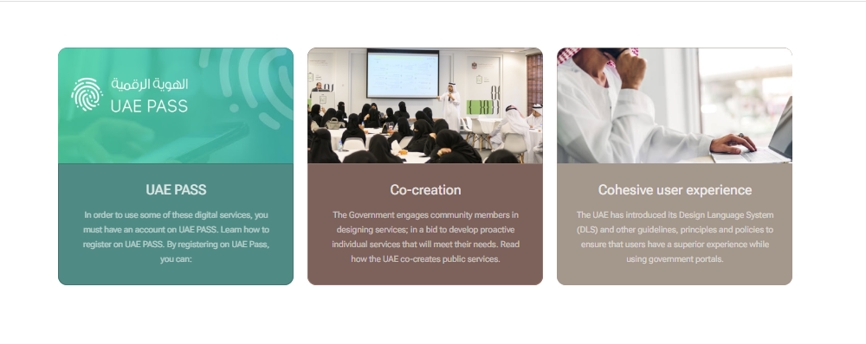

- Featured videos
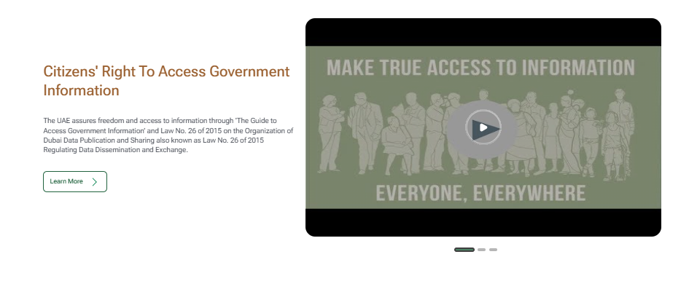
This section displays videos that provide guidance on the UAE government’s digital services, initiatives and related topics. Users can watch the video and click on ‘Learn More’ to get further information.

About The UAE
The ‘About the UAE’ page displays various topics such as: the UAE’s history, culture, government, economy, strategies and future plans.
- Accessing the ‘About the UAE’ page
- Select ‘About the UAE’ in the top navigation bar.
- Browse the available topics:
    - Fact Sheet
    - History
    - Culture
    - Human rights in the UAE
    - The Constitution
    - The UAE Government
    - Science and technology
    - The seven emirates
    - Digital UAE
    - Strategies, policies, initiatives and awards
    - The UAE’s economy
    - Government budget and expenditure
    - The UAE’s competitiveness
    - Founders of the Union
    - The UN’s 2030 Agenda
    - UAE in the Future.
- Click on a topic of interest to find the sub-topics it covers.

- Viewing details
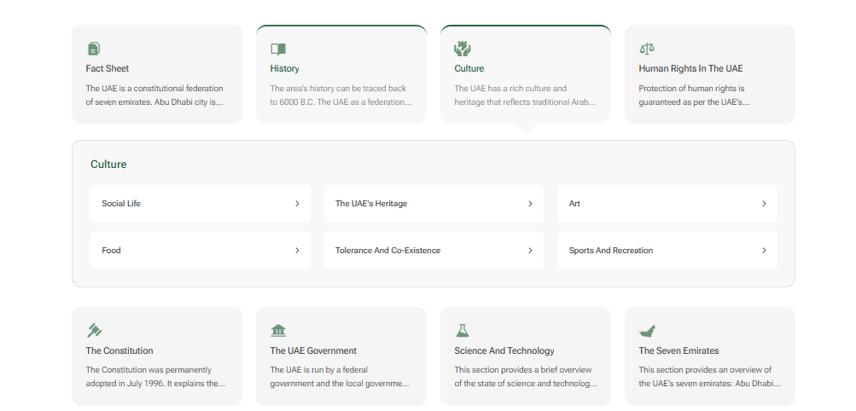
Each sub-topic provides detailed information. To view a sub-topic:
- click on a sub-topic card and
- find detailed information and related resources.

- Featured information
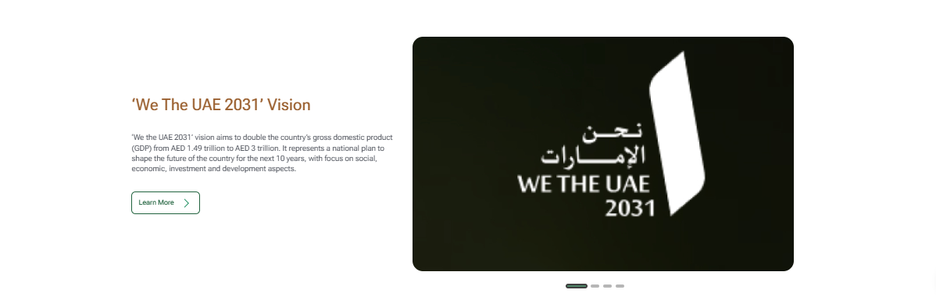
The ‘Featured information’ section display key national visions and initiatives. You can click on ‘Learn More’ to know more about the initiatives and use the slider to view more initiatives.

Media
The Media page displays select government news items, events, videos, and media-related information in the UAE. It serves as a central hub for staying informed about government announcements, initiatives and public activities.
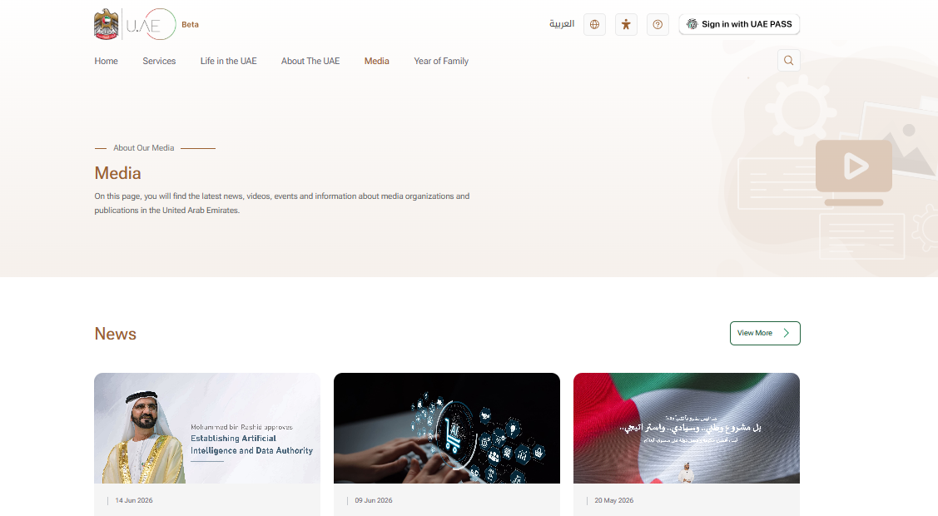
- Accessing the Media page
- Select Media from the top navigation bar.
- Browse the sections: news, events, videos, other types of media and media information.
- Click on ‘View More’ to access additional information on a particular section.
- News, events and videos

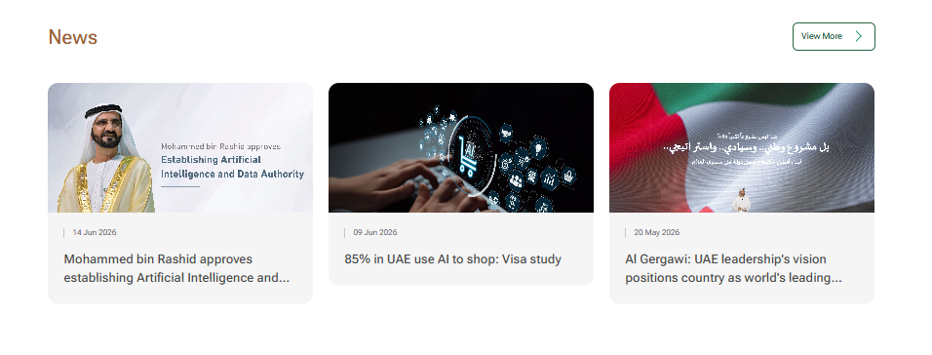
These sections contain news, events and videos relating to the UAE Government.

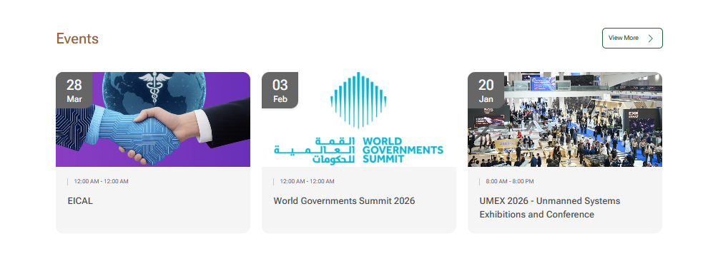

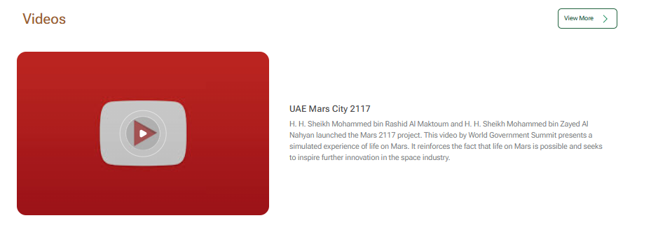

- Other types of media
This section includes additional media channels such as newsletters and podcasts.
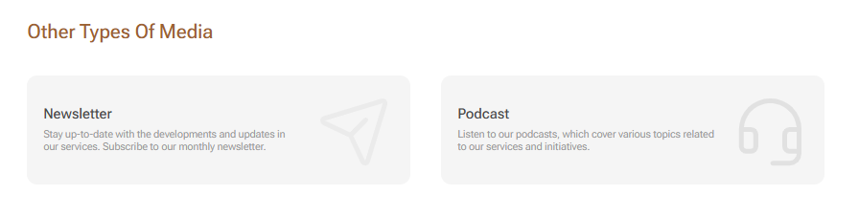
In this section, you can:
- click on Newsletter to read older official newsletters from TDRA and
- click on Podcast to listen.

- Media Information
The ‘Media Information’ section provides information about the media sector in the UAE and the government’s role in supporting its growth and reach.
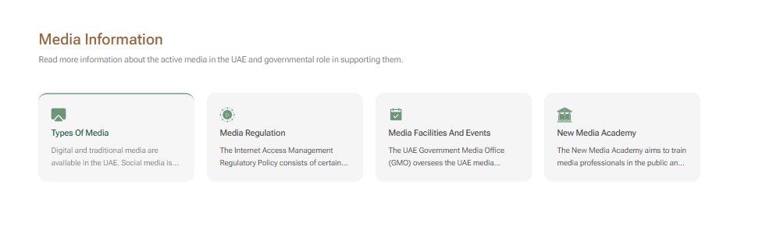
- Browse topics such as types of media, media regulation, media facilities and events, and New Media Academy.
- Click on a topic card to read more about it.

Year of Family
The ‘Year of Family’ page provides information about initiatives, services and programmes that strengthen the wellbeing of a family, fortify social cohesion and enhance quality of life.
- Accessing the ‘Year of Family’ page
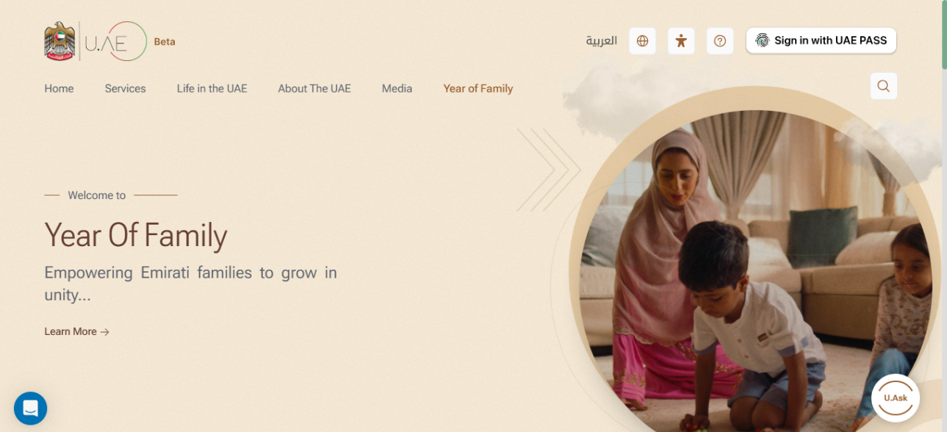
- Select ‘Year of Family’ from the top navigation bar.
- Browse the sections: related services, Family and society, and social and family programmes.
- Click on ‘View all’ to explore its content and access additional information.

- Related Services
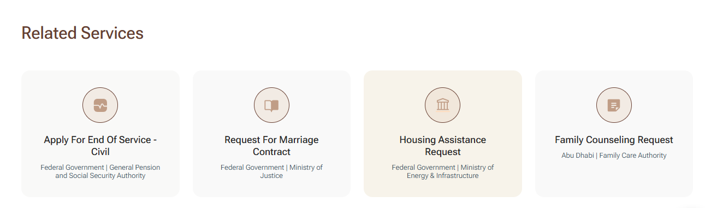
This section provides quick access to government services that support families and address their various needs. You can view government services related to family support and wellbeing along with the government entity responsible for providing it.
Click on a service card to access the service.

- Family and Society
This section provides information and guidance tailored to different stages of family life. It contains relevant resources and information about support channels.
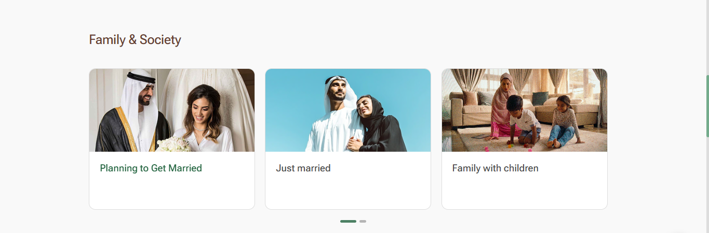
In this section, you can browse the following topics:
- Planning to Get Married
- Just married
- Family with children
- Family with senior citizens
- Family with limited income.

Use the slider controls to browse all topics in the section.

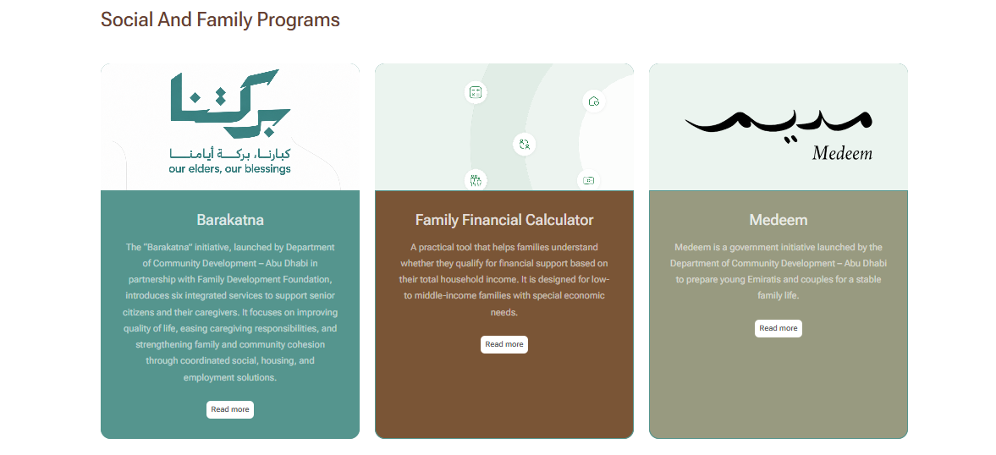
- Social and Family Programmes
This section highlights government programmes and initiatives that support families and promote their well-being. In this section, you can find out more about programmes such as:
- Barakatna
- Family Financial Calculator
- Medeem and
- Numou.
Click on ‘Read More’ to view detailed information about each programme.

- Partners
This section highlights the government entities and strategic partners that support the ‘Year of Family’ initiative and contribute to it with relevant programmes and services.
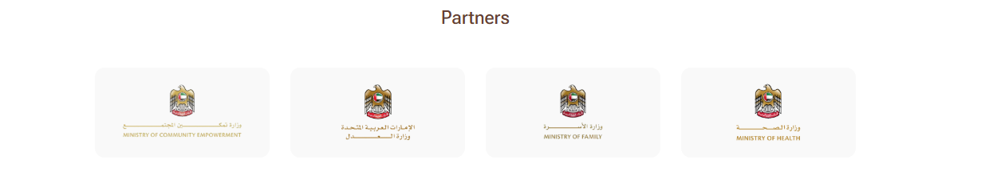

Footer navigation
The footer provides quick access to important links, resources and contact information. It is organised into four sections to help you quickly locate the information you need.
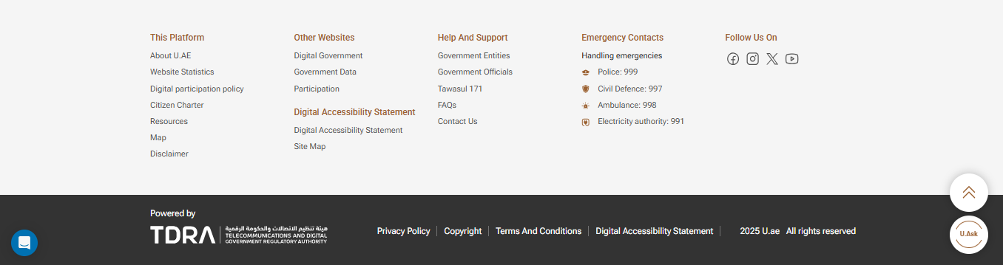

The platform
This section provides quick access to key information and resources related to the U.AE platform, such as:
- About U.ae – learn about the platform's mission and background
- Website Statistics – view statistics related to the platform
- Digital Participation Policy – Find out about the platform’s digital participation policy
- Citizen Charter – view the commitments and standards for government service
- Resources – access useful resources on the platform

- Map – locate Customer Happiness Centres, emergency services and points of interest
- Disclaimer – view the platform’s disclaimer.

Other Websites
This section provides quick access to related UAE Government portals and supporting resources, such as: Digital Government, Government Data and Participation. Also, find the Digital Accessibility Statement and Site Map of this platform.

Help and Support
This section contains contact information and links to:
- Government Entities
- Government Officials
- Tawasul 171. (the national customer relationship management system)

Also find answers to FAQs and
- details for contacting the team behind this platform.

Emergency Contacts
This section provides direct phone numbers for important emergency services in the UAE.
- Police: 999
- Civil Defence: 997
- Ambulance: 998
- Electricity Authority: 991

Follow Us On
This section provides links to the official accounts of the UAE Digital Government on various social media channels as follows:
- Facebook: https://www.facebook.com/uaedgov/
- Instagram: https://www.instagram.com/uaemgov/
- X: https://x.com/uaedgov
- YouTube: https://www.youtube.com/emiratesegovernment.

Legal links
This section contains important legal notices and policies related to the use of U.AE.

Floating side icons
The floating side icons are commonly used tools and support features. These icons remain accessible as you scroll up or down the platform, helping you to achieve key actions without leaving the current page.

The icons are:
- Back to Top – it takes you to the top of the current page
- Chat –you can ask questions about government services
- U.ASK – it is an AI assistant that helps you find information relating to government services through natural language interaction.

